Rational Functions Exploration I

Exploration 1: Goal: to graph the reciprocal of a quadratic.
Consider and its reciprocal .
- Predict (write in words) what the reciprocal of will look like, then make the graph of both and
Winplot directions:
- Under Equations menu, choose User Functions and define f to be the above, using the letters a, b, and c.
- Under the Anim menu, select Parameters, set a to 1, b to 3, and c to -2.
- Zoom out (page down) to an appropriate scale.

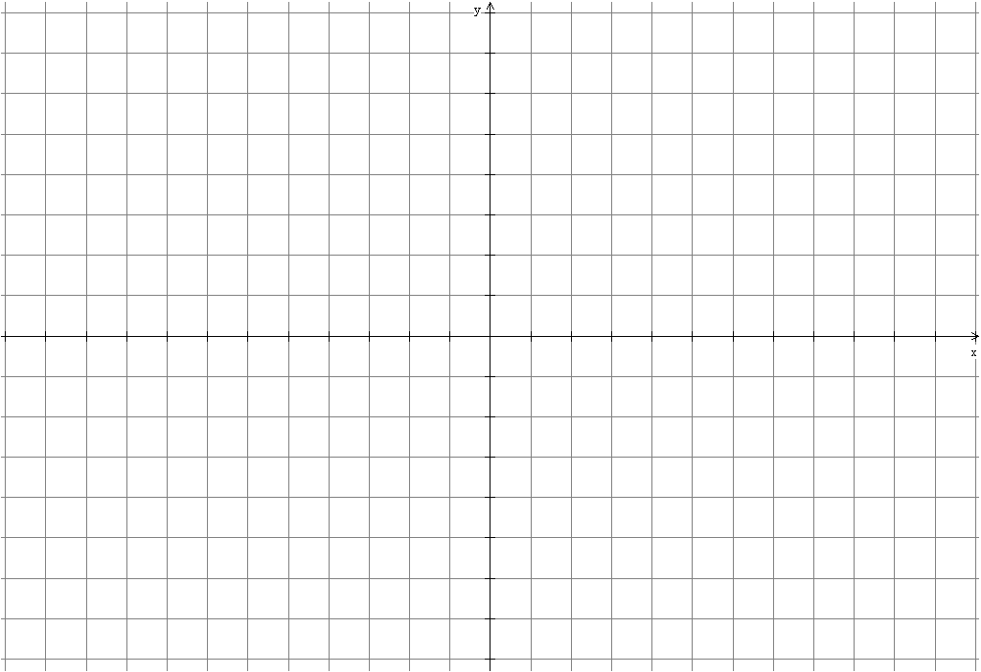
- a) What effect does changing a have on your graph? Sketch an example to help your explanation. In Winplot select Anim, Parameters, and the parameter a. Use the scrollbar to change or type any value you want in the box.

b) What effect does changing b have on your graph?

- What effect does changing c have?

Exploration 2 Goal: To predict vertical asymptotes and describe the nature of the graph near them.
Consider , again using Winplot with parameters.
- Start with , , , and . What effect does changing b, c, or d have on the graph? Sketch a case below to demonstrate.

- What if ? Why do you think the graph changed?

Exploration 3: Goal: generalize explorations 1 and 2.
- Explore the general case: . Write your generalization below with two sketched examples. For this exploration stick with just three factors in the denominator, but vary the powers until you can make a conjecture. Write down the rules you used with your examples you sketched.

Write a few sentences that summarizes you conclusions about rational functions of the type

